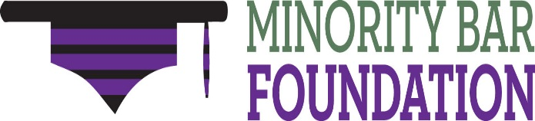
Advancing Diversity in the Legal Profession
A 501(c)(3) Nonprofit Corporation
39th Annual Awards Ceremony
Thursday, September 15, 2022 – 5:30 p.m.
Patrick’s Rooftop - 500 Pearl Street, Buffalo, New York

SPONSORSHIP OPPORTUNITIES
Please choose your sponsorship level

PLATINUM SPONSOR - $5,000  - Six tickets to Scholarship & Awards program  - Acknowledged as sponsor during Scholarship & Awards program  - Listed on the Minority Bar Foundation’s website as a Platinum Sponsor for this year’s event | GOLD SPONSOR – $3,500  - Four tickets to Scholarship & Awards program  - Acknowledged as sponsor during Scholarship & Awards program  - Listed on the Minority Bar Foundation’s website as a Gold Sponsor for this year’s event
SILVER SPONSOR – $2,500  - Three tickets to Scholarship & Awards program  - Acknowledged as sponsor during Scholarship & Awards program  - Listed on the Minority Bar Foundation’s website as  a Silver Sponsor for this year’s event | BRONZE SPONSOR – $1,500  - Two tickets to Scholarship & Awards program  - Acknowledged as sponsor during Scholarship & Awards program  - Listed on the Minority Bar Foundation’s website as a Bronze Sponsor for this year’s event
INDIVIDUAL TICKETS – $100.00/each

Please submit this completed form to Tracy Knisley at tknisley@hselaw.com by September 1, 2022.

Name:__________________________________________________________________________________

Company:________________________________________________________________________________
Address:_________________________________________________________________________________
Telephone No. _____________________________ Email address:___________________________________

